Unit 1
- Assume gadgets are sold in a competitive market, the equilibrium price is $6, and the equilibrium quantity is 500 units.
(a) Using the numerical values above, draw a correctly labeled graph of the market for gadgets and show each of the following.
(i) The equilibrium price (ii) The equilibrium quantity
(b) At a price of $8 per unit, will there be a surplus or a shortage in the market? Explain.
(c) Assume gadgets now become more popular. On your graph in part (a), show the effect of the increase in gadgets' popularity on the equilibrium price and quantity of gadgets.
(d) Assume instead there is an increase in the price of tin, a major input in producing gadgets. What will be the effect of an increase in the price of tin on the market for gadgets?
(e) If both changes in part (c) and part (d) occurred simultaneously, will the equilibrium quantity of gadgets increase, decrease, remain unchanged, or be indeterminate? Explain.
- Zeetopia and Freshland are two small tropical islands that use the same amounts of resources to produce mangoes and coconuts as shown in the table below
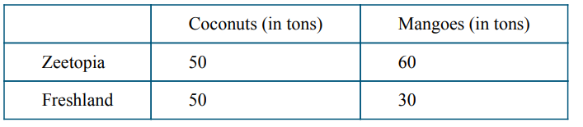
(a) Which island has an absolute advantage in producing coconuts? Explain.
(b) Which island has a comparative advantage in producing coconuts? Explain.
(c) Assume Zeetopia and Freshland decide to specialize according to their comparative advantages and 1 ton of coconuts is exchanged for 1 ton of mangoes. Are specialization and trade under these terms beneficial to both Zeetopia and Freshland? Explain.
(d) Assume the two islands experience constant opportunity costs in the production of the two products. Draw a correctly labeled graph illustrating Zeetopia’s and Freshland’s production possibilities, showing coconuts on the horizontal axis and mangoes on the vertical axis. Plot the numerical values from the table above on your graph.
(e) On your graph in part (d), show a combination of coconuts and mangoes, labeled as point X that is unattainable for Freshland but feasible and inefficient for Zeetopia.

Unit 2
- The nation of Kona cultivates coffee beans and cassava, from which all their consumer goods are produced. 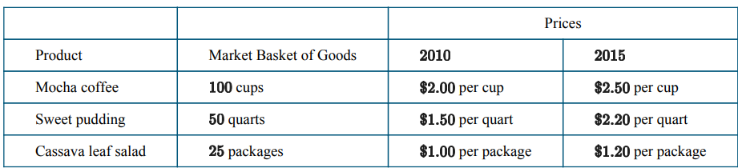
(a) Calculate the cost of the market basket of goods in the table in and in . Show your work.
(b) Use as the base year to calculate the price indices for and for the market basket of goods in the table. Show your work.
(c) In order for a citizen of Kona to maintain the same standard of living between and , what percentage change in nominal income would be needed? Explain
- The table below shows unemployment and labor force statistics for an economy.
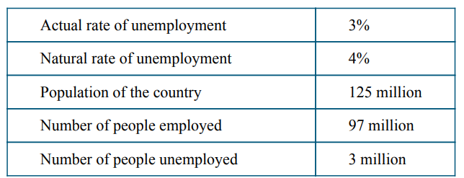
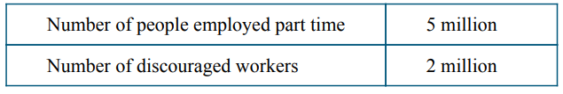
(a) Calculate the size of the labor force. Show your work.
(b) Calculate the labor force participation rate. Show your work.
(c) Given the state of the economy described in the table, is actual real output less than, greater than, or equal to potential real output? Explain.
(d) Calculate what the cyclical unemployment rate would be if the actual rate of unemployment increased to 5 percent. Show your work.
(e) Suppose discouraged workers reenter the labor force and find employment. Will the actual rate of unemployment increase, decrease, or stay the same?

Unit 3
- The economy of Country X is at full employment.
(a) Draw a correctly labeled graph of the long-run aggregate supply, short-run aggregate supply, and
aggregate demand curves, and show each of the following.
(i) Current price level, labeled
(ii) Current real output, labeled
(b) Assume that household income increases as a result of recent economic prosperity in Country X. On
your graph in part (a), show the effect of the increase in household income on real output and price
level.
(c) What will be the effect of the change identified in part (b) on unemployment in Country X?
(d) Will the change in real output shown in part (b) be smaller or larger in the presence of automatic
stabilizers? Explain.
- The economy of Newland is in short-run macroeconomic equilibrium. The current real output is $400 billion, and the full employment output is $500 billion. The marginal propensity to consume is 0.8.
(a) Is the economy experiencing a recessionary output gap or an inflationary output gap? Explain.
(b) Assume Newland’s government is considering taking action to close the output gap identified in part (a).
(i) Calculate the minimum change and indicate the direction of change in government spending required to shift the aggregate demand curve to close the output gap. Show your work
ii) If instead Newland’s government changes taxes without changing government spending, calculate the minimum change and indicate the direction of change in taxes required to shift the aggregatedemand curve to close the output gap. Show your work.
(c) Which fiscal policy action, changing government spending or changing taxes, is more effective in
closing the output gap? Explain.
(d) Assume instead Newland’s government decides not to take any policy action. Will short-run
aggregate supply increase, decrease, or stay the same in the long run? Explain.

Unit 4
- Commercial banks in Country A hold no excess reserves. The required reserve ratio is 0.1. The central bank of Country A has become concerned about a steep decline in investment spending.
(a) Calculate the simple money multiplier. Show your work.
(b) Identify an open market operation that Country A’s central bank is likely to implement to address the decline in investment spending.
(c) Draw a correctly labeled graph of the money market and show the effect of the central bank’s policy identified in part (b) on the nominal interest rate.
(d) Explain the effect of the change in part (c) on aggregate demand in the short run.

- A national newspaper’s headline reads “Business Confidence Reaches Highest Level in 5 Years.”
(a) Draw a correctly labeled graph of the loanable funds market, and show the effect of high business
confidence on the equilibrium real interest rate.
(b) Assume the government increases its spending on capital projects and infrastructure. Would
financing the increased government spending by borrowing result in a higher, a lower, or the same
equilibrium real interest rate? Explain.
(c) How will the increase in government spending financed by borrowing affect national savings?
(d) If the expected inflation rate decreases to zero, will the nominal interest rate be greater than, less
than, or equal to the real interest rate? Explain.

Shorter Questions

Unit 1
- Nations A and B produce only chairs and bicycles. If each laborer in Nation A can produce twice as many chairs as each laborer in Nation B, then which of the following is necessarily true?
(A) Nation A has a comparative advantage in chairs.
(B) Nation A has a comparative advantage in bicycles.
(C) Nation A has an absolute advantage in chairs.
(D) Nation B has an absolute advantage in bicycles.
(E) Nation A should specialize in producing chairs.

Unit 2
- A lender will realize unexpected benefit when the
(A) actual inflation rate is higher than the anticipated inflation rate
(B) actual inflation rate is lower than the anticipated inflation rate
(C) rate of interest is greater than the actual rate of inflation
(D) rate of interest is less than the actual rate of inflation
(E) rate of interest equals the actual rate of inflation

Unit 3
- If the central bank holds interest rates constant, an autonomous decrease of 10 million in investment spending will most likely result in
- a decrease of exactly 10 million in gross domestic product
- a decrease of more than 10 million in gross domestic product
- an increase of 10 million in taxes to offset the decrease in investment
- an increase of 10 million in aggregate supply to offset the decrease in investment
- an increase in the cost of loans for investment purposes
- Gross private domestic investment includes which of the following?
- Changes in business inventories
- National defense spending
- New durable goods purchased by households
- Transfer payments
- Depreciation of government goods
- In the long run, a fully anticipated increase in the inflation rate will
(A) increase real national output
(B) increase the nominal interest rate
(C) decrease real national output
(D) decrease the real interest rate
(E) shift the long-run Phillips curve to the right
- Which of the following will cause an increase in real output in the short run?
(A) A decrease in productivity
(B) A decrease in wages
(C) A decrease in government expenditure
(D) An increase in reserve requirements
(E) An increase in the discount rate

Unit 4
- When a central bank conducts open market bond sales, the money supply, interest rate, and aggregate demand will change in which of the following ways in the short run?
Money supply Interest Rate Aggregate Demand
- Decrease Increase Decrease
- Decrease Decrease Increase
- Decrease Increase Increase
- Increase Decrease Increase
- Increase Decrease Decrease
- An increase in money demand will cause which of the following?
(A) A decrease in the nominal interest rate
(B) A decrease in bond prices
(C) A decrease in the money supply
(D) An increase in the price level
(E) An increase in the natural rate of unemployment
- The graph above shows aggregate demand (AD), short-run aggregate supply (SRAS), and long-run aggregate supply curves for an economy. Based on the graph, cost-push inflation is caused by a movement from
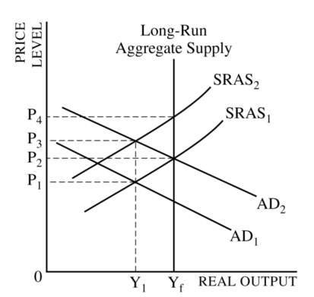
(A) SRAS1 to SRAS2
(B) SRAS2 to SRAS1
(C) AD1 to AD2
(D) AD2 to AD1
(E) Y1 to Yf
- Assume a country’s government has a balanced budget. If the economy goes into a recession, what will happen to the government’s budget in the short run?
(A) It will be in surplus, because the government will increase its spending.
(B) It will be in surplus, because there will be an automatic decrease in unemployment payments.
(C) It will be in deficit, because the government will raise the tax rates.
(D) It will be in deficit, because the price level will decrease.
(E) It will be in deficit, because there will be an automatic decrease in tax receipts.
- Assume that the government finances its spending by borrowing from the public. If the government increases deficit spending, the price of previously issued bonds and the real interest rate will change in which of the following ways?
Price of Bonds Real Interest Rate
(A) Decrease Decrease
(B) Decrease Increase
(C) Increase Decrease
(D) Increase No change
(E) Increase Increase
- Which of the following accurately describes the federal funds rate?
(A) The interest rate that banks charge state governments
(B) The interest rate that banks charge other banks for overnight loans
(C) The interest rate that banks pay on long-term savings
(D) The interest rate on personal loans
(E) The interest rate on government bonds
- If the government implements an expansionary fiscal policy, what action can the central bank take to maintain a stable interest rate?
(A) Increase the required reserve ratio
(B) Increase personal income tax rates
(C) Decrease personal income tax rates
(D) Sell government bonds
(E) Buy government bonds

Unit 5
- Which of the following is most likely to promote long run economic growth?
- An increase in government transfer payments
- An increase in income taxes for middle class households
- An increase in tax credits for business spending on research and development
- An increase in unemployment compensation
- An increase in financial capital outflow
- Given a constant velocity of money, in the short run a 5 percent increase in money supply will translate to a 5 percent increase in
(A) government budget deficit
(B) real gross domestic product
(C) nominal gross domestic product
(D) real interest rates
(E) nominal interest rates

Answers

